Module 10.2 Assignment
Kobe Alexander
5/17/2026
Bellevue University
CSD 325

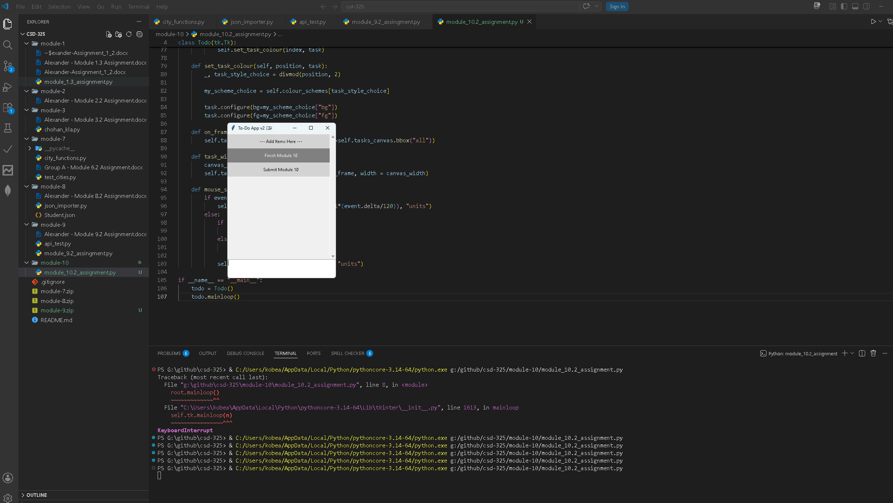
After Changes:
